Real Field Tomato Disease Classification using EfficientNetB0

Member 1 (Adam Optimizer)
Final Report :

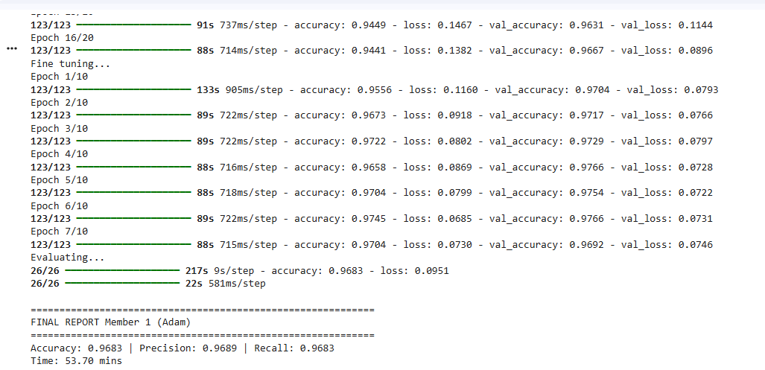

The Training History Graph (Accuracy/Loss lines):
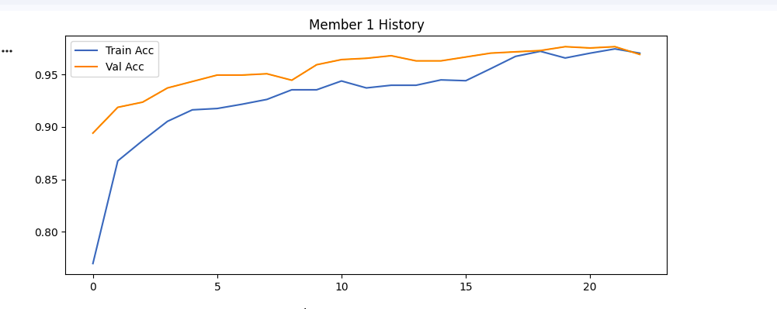
The Confusion Matrix Heatmap:
